**ABHINAV SHARMA – 4 CREDITS**

**SHYAM RAJENDRAN - 4 CREDITS**

**SAIKAT ROYCHOWDHURY - 4 CREDITS**

## Greedy Search

**Path Explored : 78 Path Cost : 74**

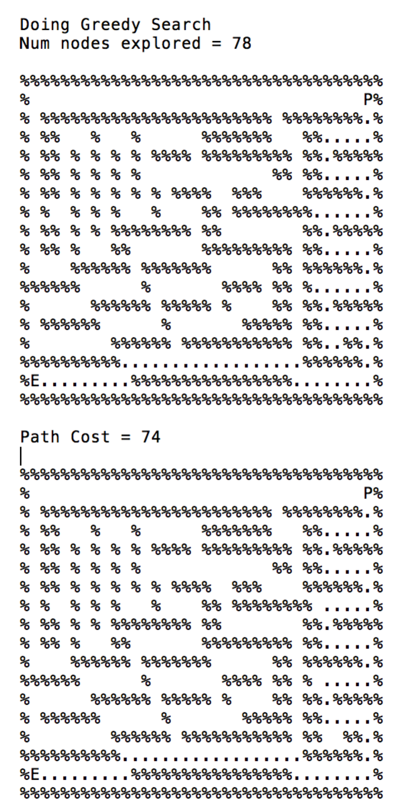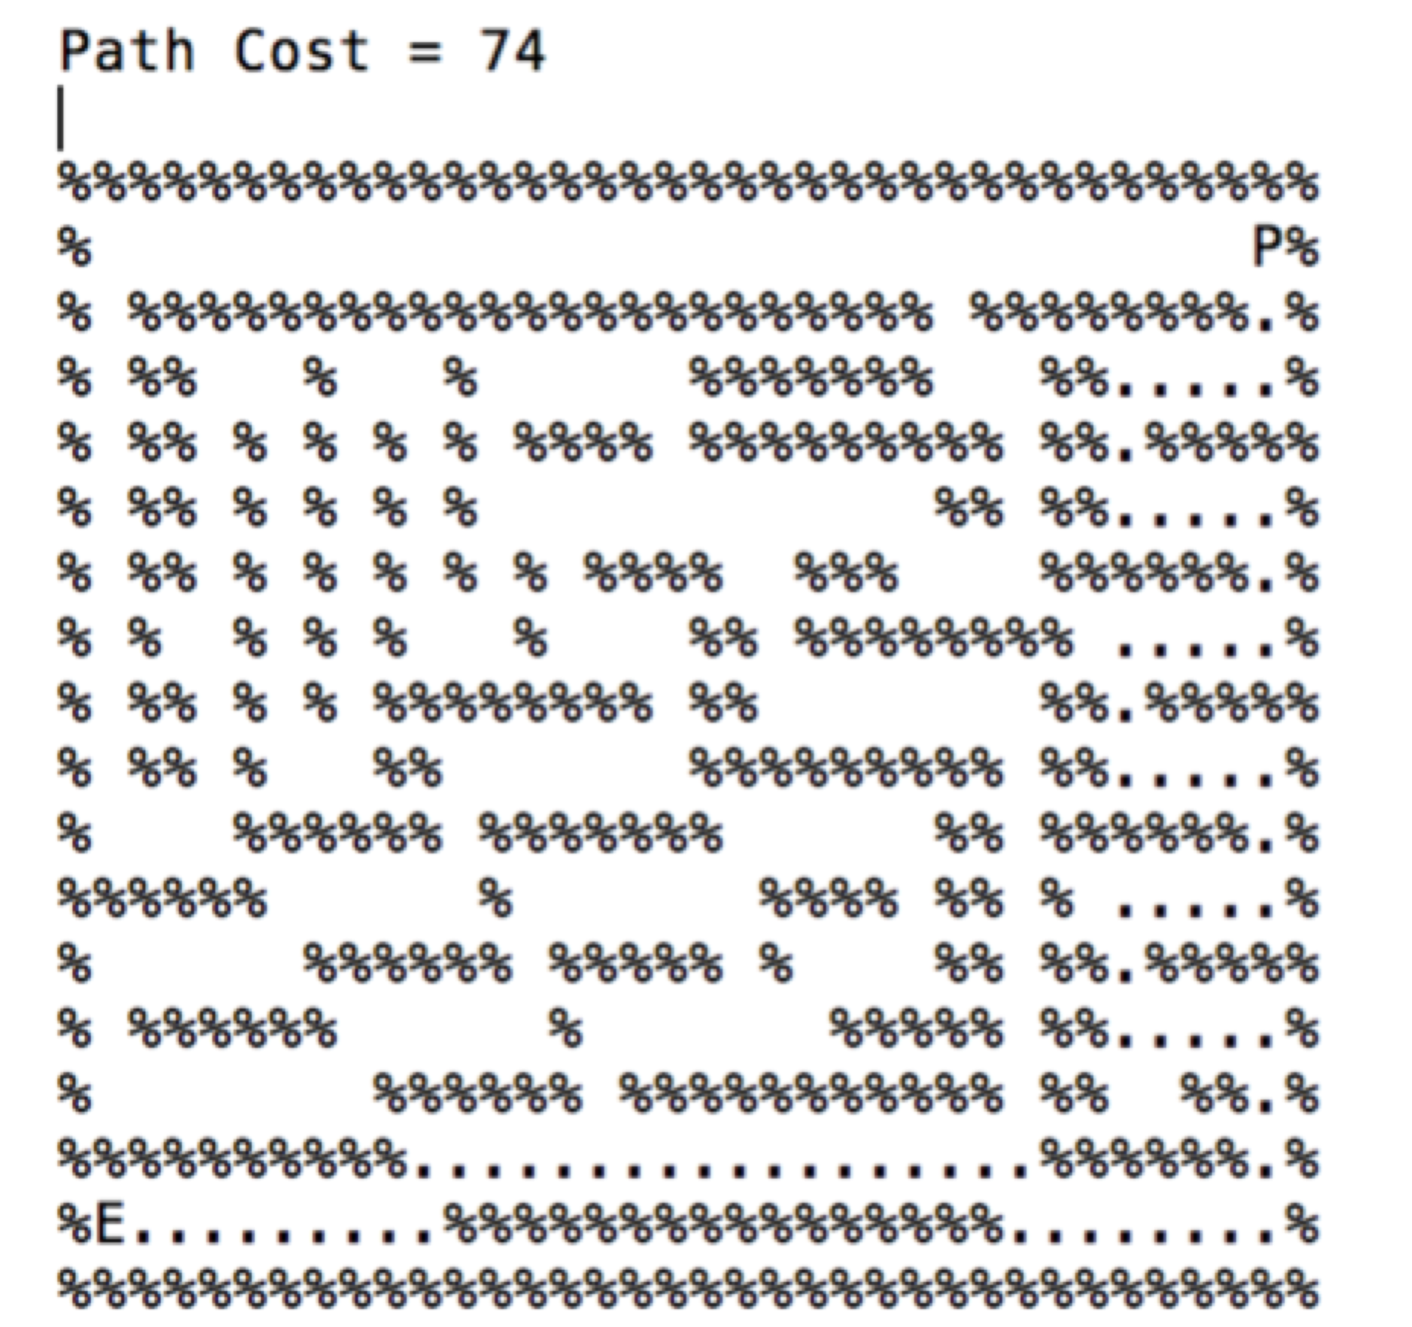

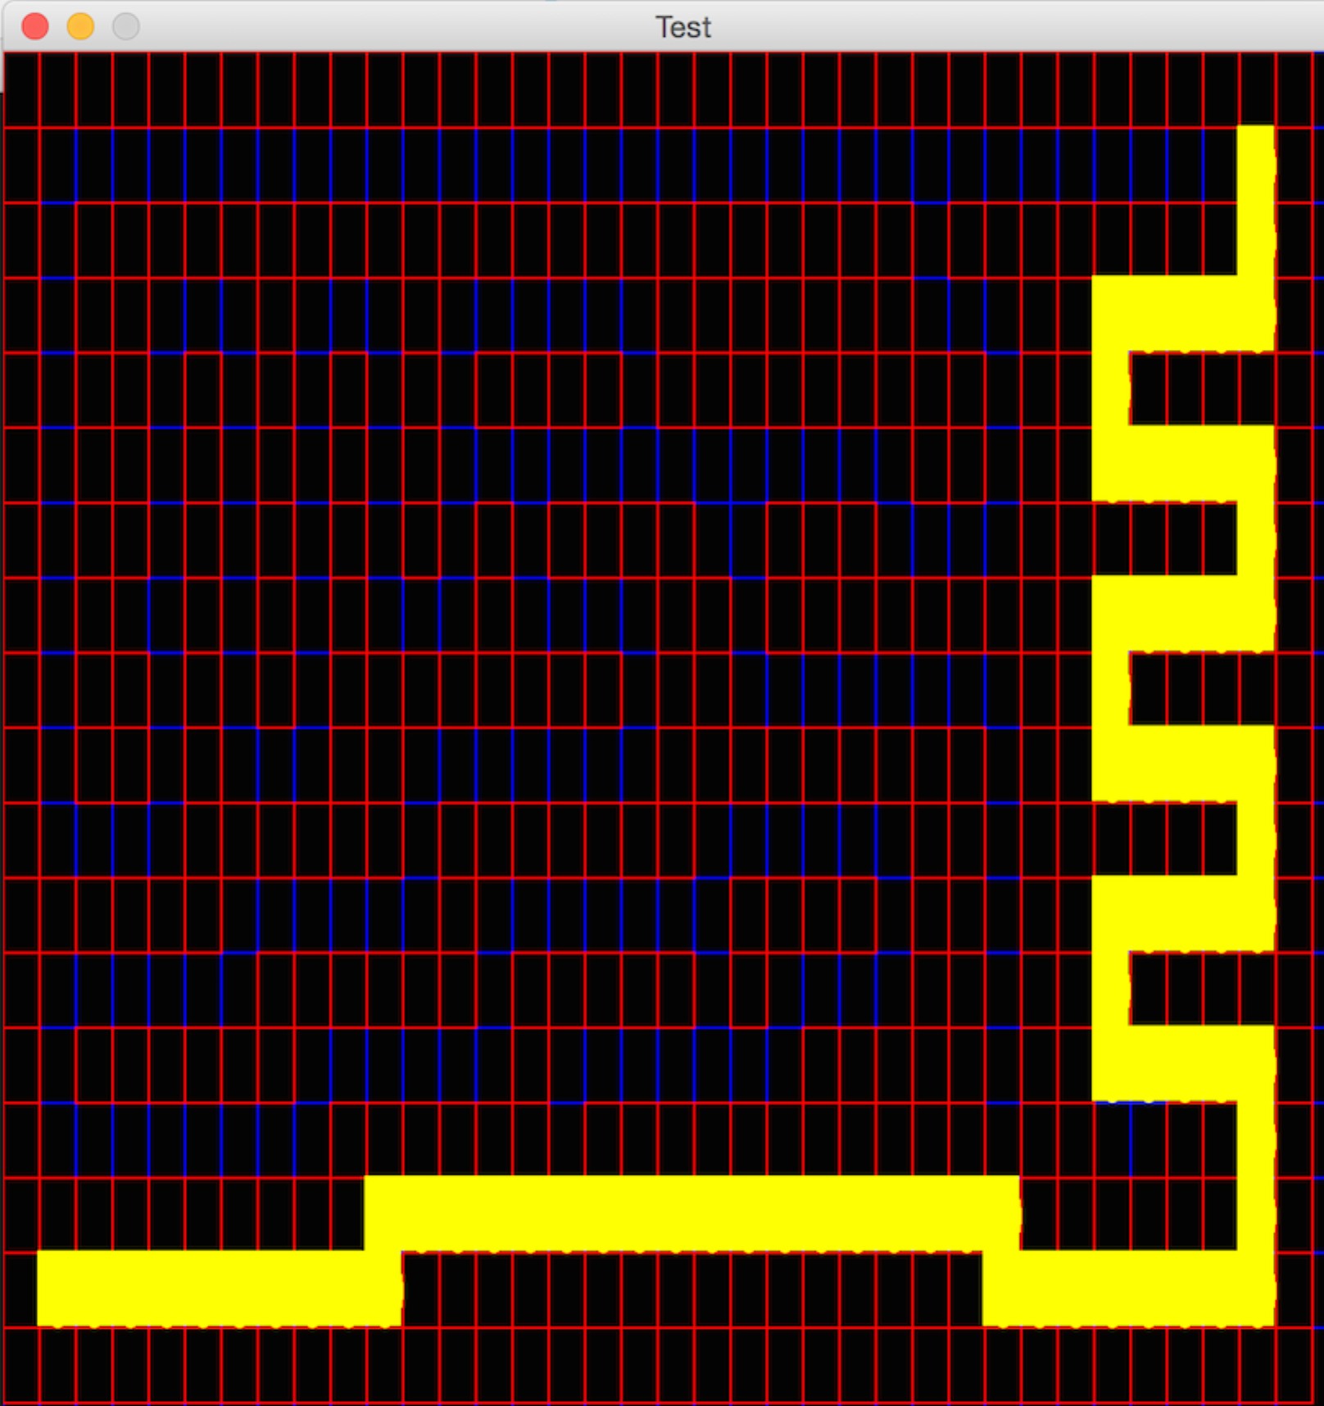

**Greedy Search Path Trace**

# Bread First Search

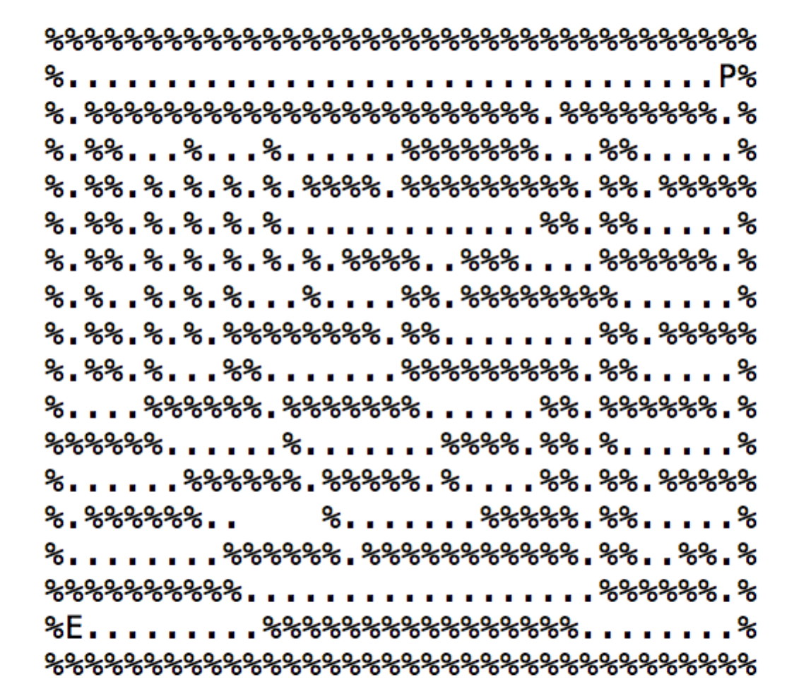**Path Explored : 269 Path Cost : 68**

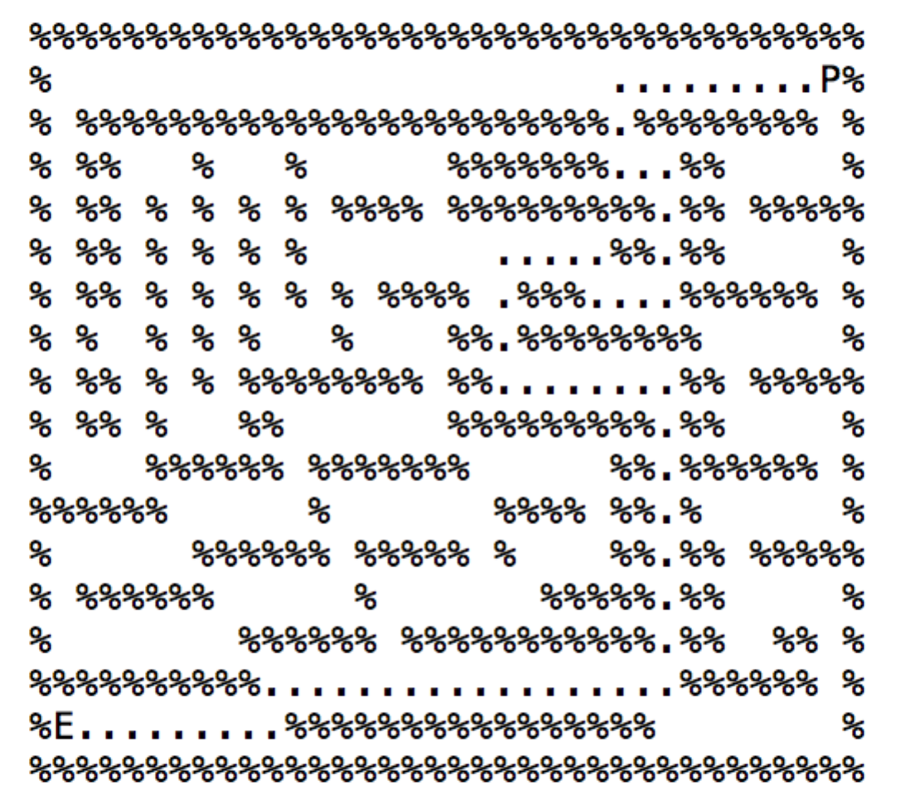

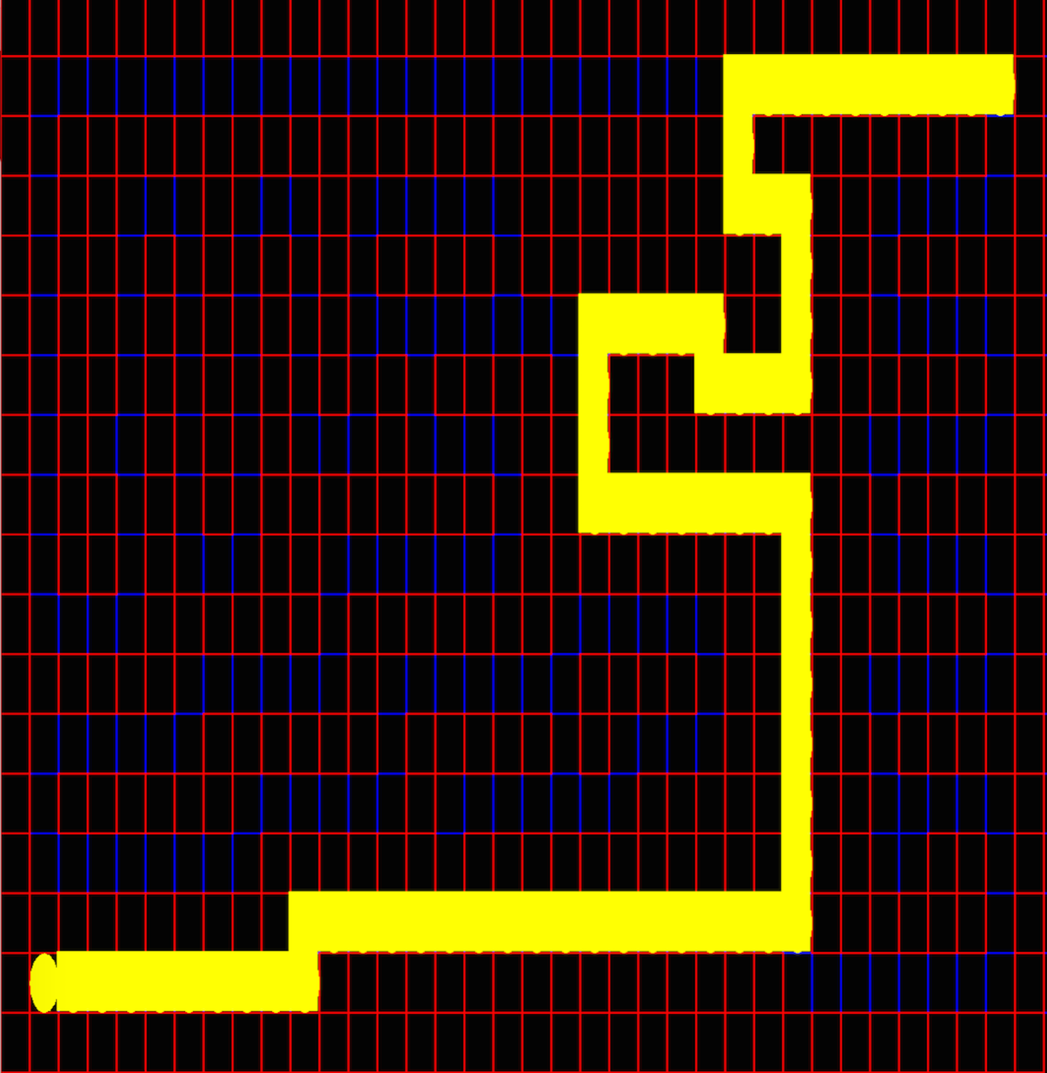

**Breadth First Search Path Trace**

# Depth First Search

**Path Explored : 144 Path Cost : 130**

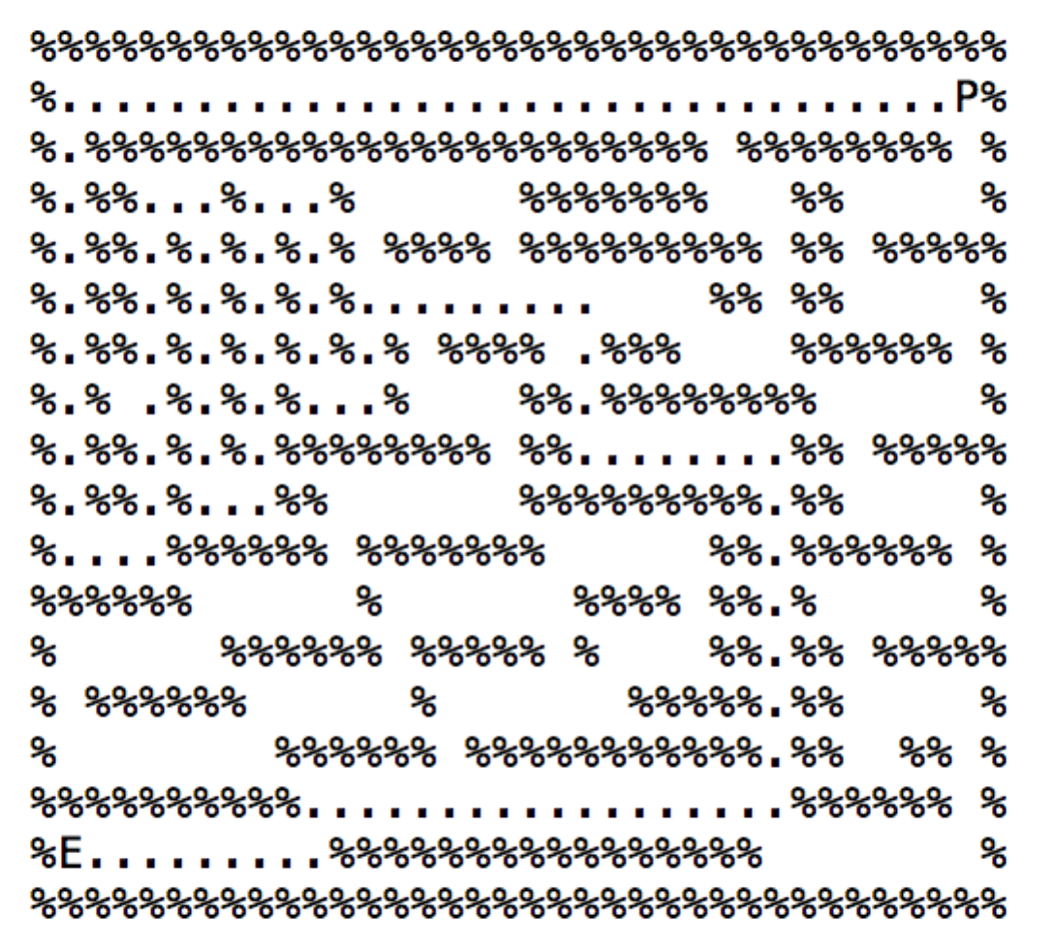

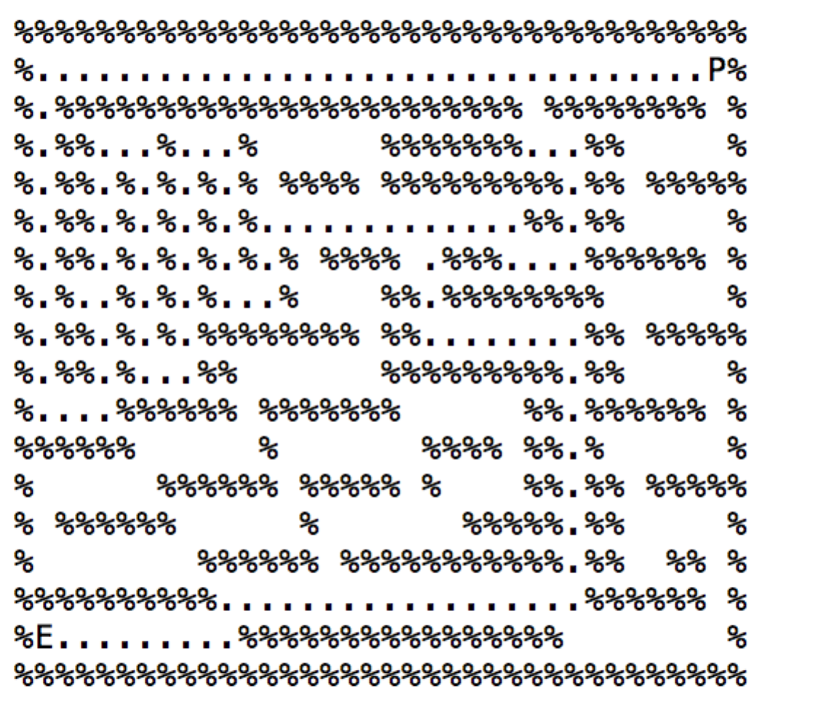

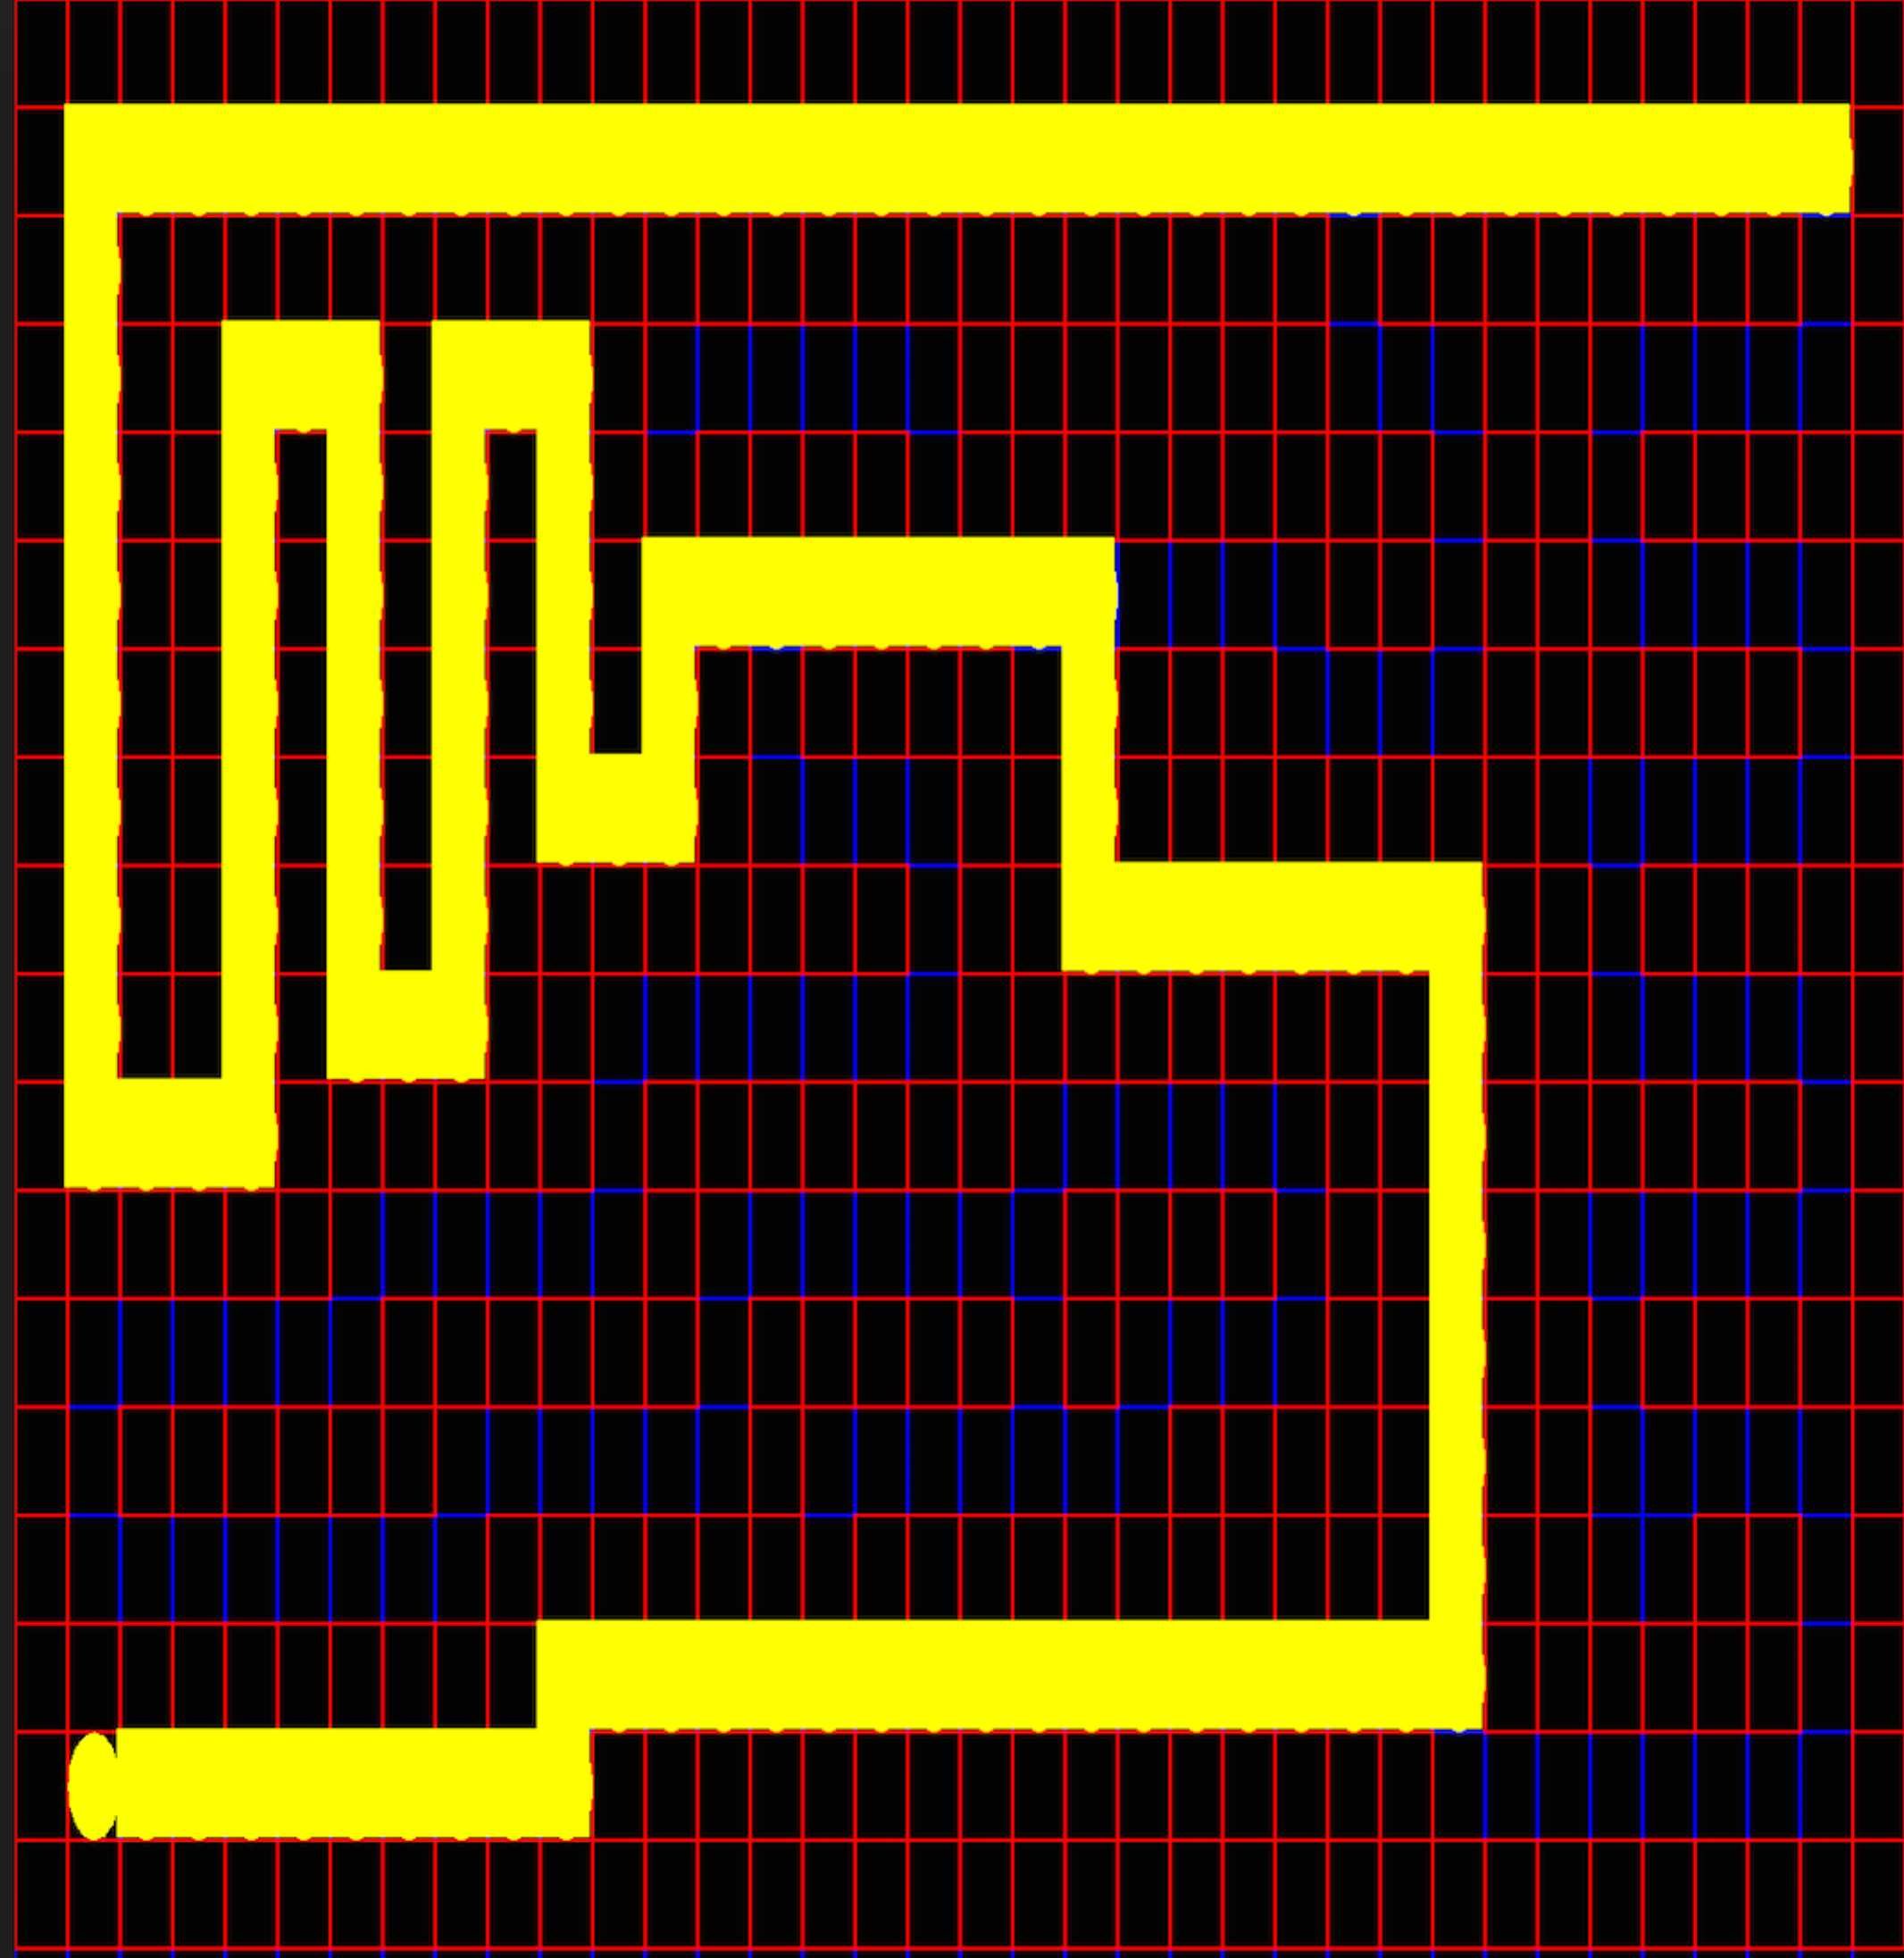

**Depth First Search Path Trace**